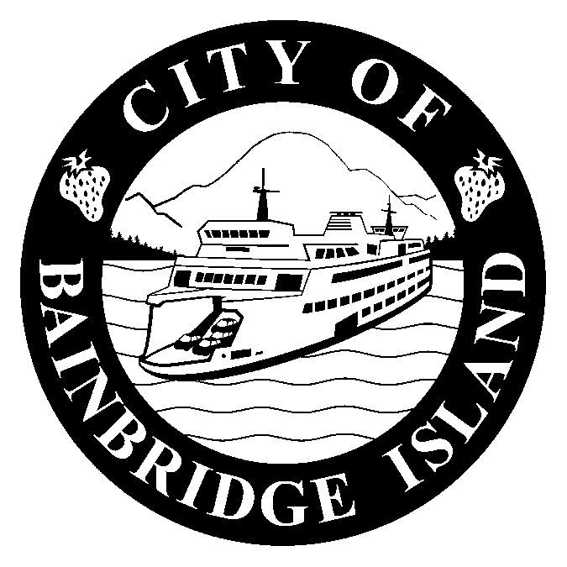
HISTORIC PROPERTY REGISTER
NOMINATION

Dear Historic Property Owner,

The City of Bainbridge Island and Historic Preservation Commission (BIHPC) welcomes your interest in seeking placement on the Bainbridge Island Historic Register. Preserving a community’s cultural and historic resources is an autobiographical undertaking which provides a lasting reference of place for future generations. Your property is valuable to Bainbridge Island’s history. A listing on the Historic Register will give exclusive access to City, County, and State economic and technical resources to support its preservation and recognition of significance.

Register listing will:

Promote sustainable development by recycling existing resources

Encourage interest of local artisans and builders in the preservation ethic

Typically increase property value

Provide eligibility for a ten-year special property tax valuation for substantial improvements

Include a BIHPC card giving discounts from merchants for approved rehabilitation projects

Give access to possible State and National grants for rehabilitation

Please submit the enclosed forms with the required information and photos to:

Bainbridge Island Historic Preservation Commission
City of Bainbridge Island
Madison Ave. N
Bainbridge Island, WA 98110

For help or information call: (206) 780-3774

Email: ped@ci.bainbridge-isl.wa.us

http://www/ci/bainbridge-isl.wa.us/hpc.asp

Page 1 of 6
BIHPC – HISTORIC PROPERTY
REGISTER NOMINATION

PROPERTY OWNER(S) INFORMATION:

Names(s): ______________________________________________________________

Mailing
Address: ______________________________________________________________

______________________________________________________________

Telephone: ______________________________________________________________

Email
Address: ______________________________________________________________

PROPERTY INFORMATION:

Address or
Location ______________________________________________________________

______________________________________________________________

Tax Parcel # ______________________________________________________________

Legal Description, and UTM reference: (UTM refers to the Universal Transverse Mercator Location on the United States Geological Survey (USGS) map using a Global Positioning System (GPS)

_____________________________________________________________

_____________________________________________________________

_____________________________________________________________

Zone Easting Northing Zone Easting Northing

1 _______ _______ _______ _______ _______ _______

2 _______ _______ _______ _______ _______ _______

Note: UTM reference can be provided by the City

Page 2 of 6
BIHPC – HISTORIC PROPERTY
REGISTER NOMINATION

NOMINATION INFORMATION:

Property nominated by: Property owner _______ BIHPC _____ Other _____

Name _______________________________________________________________________

Address _____________________________________________________________________

I/we are the owners of said property and hereby acknowledge this nomination. I/we agree to comply with current BI City ordinances pertaining to inclusion on the Bainbridge Island Historic Register if granted. I/we understand I/we reserve the right to withdraw this property from the register at any time we so choose.

Signed: ___________________________________________ Date: __________________

CATEGORY OF PROPERTY: (check appropriate box):

Building _____ Structure _____ Site _____ Cemetery/burial Archeological
Site _____ site _____

Status: Occupied _____ Vacant _____ In transition _____

HISTORIC FUNCTION: CURRENT FUNCTION:

CRITERIA FOR ELIGIBILITY: (check as many as relevant):

Any building, structure, site or object, whether publicly or privately owned, may be designated for listing on the local register if it is significantly associated with the history, architecture, archaeology, engineering, or cultural heritage of the community; it has physical integrity; it is at least fifty-years old, or is of lesser age but has exceptional importance; and it qualifies as at least one of the following:

_____ 1. Is associated with events that have made a significant contribution to the broad patterns of local, state, or national settlement history.

_____ 2. Embodies the distinctive architectural characteristics of a type, time period, style, or method of design or construction, or represents a significant and distinguishable entity whose components may lack individual distinction.
Page 3 of 6
BIHPC – HISTORIC PROPERTY
REGISTER NOMINATION

_____ 3. Is an outstanding work of a designer, builder, or architect who has made a substantial contribution to the art.

_____ 4. Exemplifies or reflects significant elements of the City’s cultural, economic, political, aesthetic, engineering, or architectural history.

_____ 5. Is associated with the lives of persons significant in local, state, or national historical events.

_____ 6. Has yielded or may be likely to yield significant archaeological information relative to history or prehistory.

_____ 7. Is a building or structure removed from its original location, but which is significant primarily for architectural value, or which is the only surviving structure associated with a historic person or event

_____ 8. Is the birthplace or grave of a historical figure of outstanding importance.

_____ 9. Is a cemetery which derives its primary significance from age, distinctive design features, or association with historic events or cultural patterns.

_____ 10. Is a reconstructed building executed in a manner consistent with the Secretary’s Standards for Rehabilitation.

_____ 11. Is a creative and unique example of folk/vernacular architecture and design created by persons not formally trained, and which does not readily fit into formal architectural or historical categories.

_____ 12. Is listed on the National Register of Historic Places or the Washington State Register of Historic Places.

HISTORICAL SIGNIFICANCE NARRATIVE: (Describe known history of the property in
as much detail as possible: date built or established, builder (if known), owners, uses over time,
etc. (attach a continuation sheet if necessary)

______________________________________________________________________________

Page 4 of 6

BIHPC – HISTORIC PROPERTY
REGISTER NOMINATION

AREAS OF SIGNIFICANCE:

_____ A. Property is associated with events that have made a significant contribution to the settlement pattern(s) of BI history.

_____ B. Property is associated with the lives of significant person(s) in our past.

_____ C. Property embodies the distinctive characteristics of a type, period, or method of construction, or possesses high artistic value or significant and distinguishable elements apart from the whole.

_____ D. Property has yielded, or is likely to yield, information important to history or prehistory.

PROPERTY DESCRIPTION NARRATIVE: (Describe what is known of its original and current condition. If the property is a building or structure, describe in as much architectural detail as possible, including stylistic elements, known alterations, additions, etc. Attach continuation sheet if more space is required.)

_____________________________________________________________________________

_____________________________________________________________________________

_____________________________________________________________________________

DOCUMENTATION: Attach any supporting information or evidence

Written Sources: Attach, in proper bibliographical form, any books, magazines, newspapers, videos, or movies that you used to research/establish significance.

Oral History/Interviews: Attach/include in proper bibliographical form, oral histories/interviews, etc., you used to research/establish significance.

Historic Maps and Photographs: List names and/or types of maps used in research. Include copies and photographs when possible.

Assessor’s Map: Mark location of property. A copy of this map may be obtained from the Department of Planning and Community Development between the hours of 8:00 AM and
4:00 PM, Monday through Friday.

Photographs: Include at least four defining 4 x 6 exterior photographs of nominated property.
Page 5 of 6
BIHPC – HISTORIC PROPERTY
REGISTER NOMINATION

For Office Use Only:

Project #: ____________________________________________________________________

Application Completed: ________________________________________________________

Additional Information Needed: _________________________________________________

____________________________________________________________________________

HPC Meeting Scheduled For: ___________________________________________________

HPC Public Meeting Notice Published: ___________________________________________

Property Posted On: ___________________________________________________________

Notice Mailed to Interested Parties: _______________________________________________

Page 6 of 6

